# C3- S7 PRACTICE

# Ex 1: Can I go to PNC?

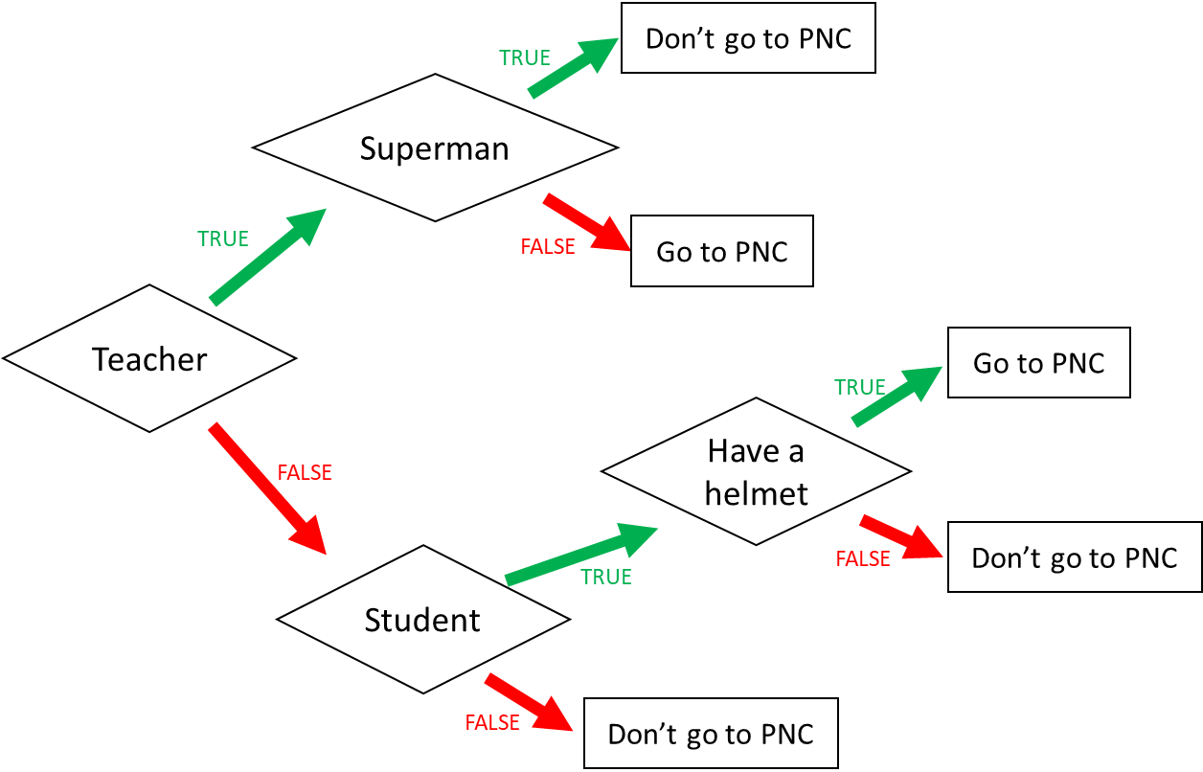

1. I am a teacher and I am superman, can I go to PNC?

Teacher and superman or go to PNC.

1. I am not a teacher and not a student, can I go to PNC?

Teacher and don’t student and don’t go to PNC.

1. When can I go to PNC? (Express the condition using a Boolean expression)

I go to PNC if:

Teacher or student and have a helmet and go to PNC.

Teacher and supeman or go to PNC.

Ex 2: What do I eat?

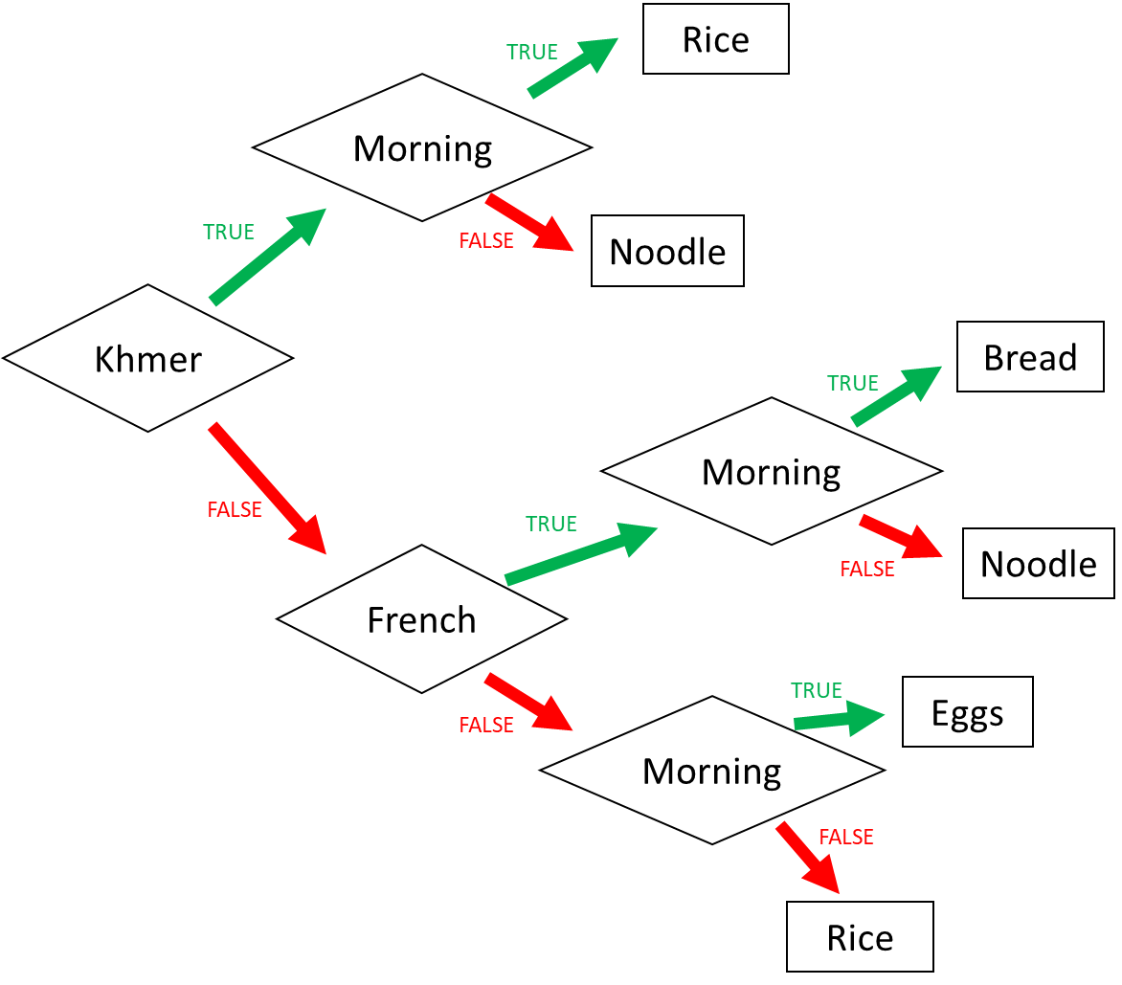

1. I am Khmer and it is the evening. What do I eat?

Khmer and morning and noodle.

2. I am French and it is the morning. What do I eat?

Khmer and french and morning and eggs.

3. I am American and it is the morning. What do I eat?

Khmer and american and moning and bread.

4. When do I eat rice? (Express the condition using a Boolean expression)

I eat rice if:

Khmer and french and morning and rice.

Khmer and morning and rice.

Ex 3: Do I go to the pool?

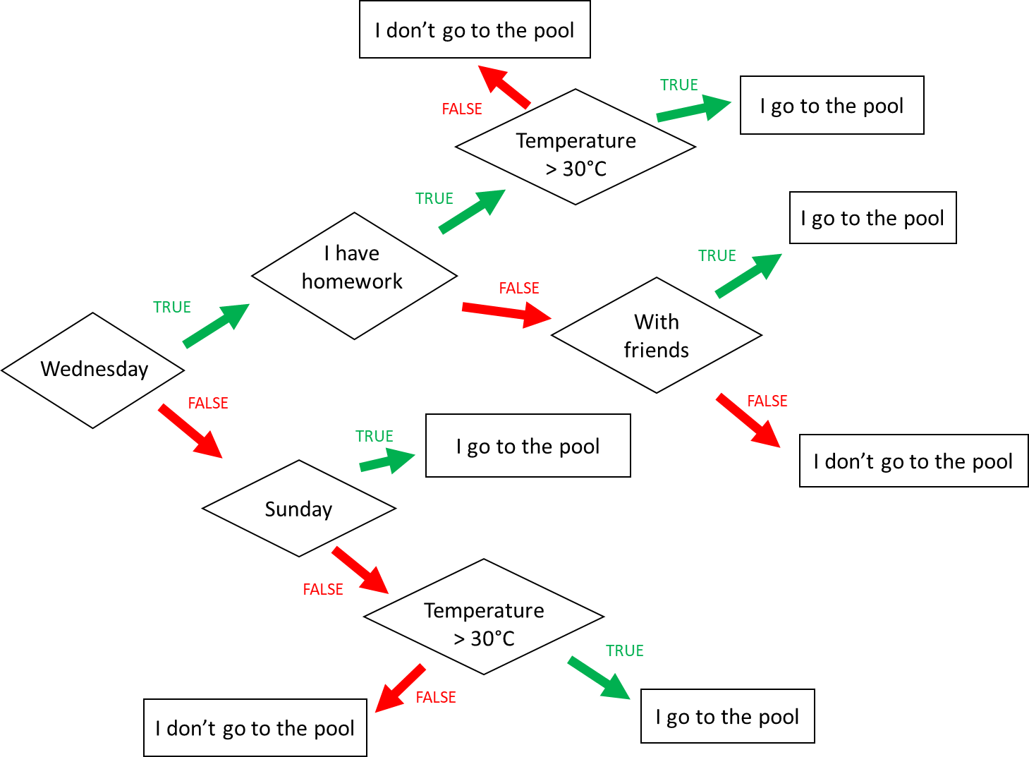

**Input 1 :**

* Wednesday
* Temperature = 31°C
* **Homework**

🡪 Do I go to the pool ?

Wednesdsy and i have hoework and temerture and i go to the pool.

**Input 2 :**

* Monday
* Temperature = 35°C
* I have no friend

🡪 Do I go to the pool ?

Wednesday and Sunday and temperture>31°C and i go to pool.

**Input 3 :**

* Wednesday
* I have **no** homework
* I’m with friends
* Temperature = 28°C

🡪 Do I go to the pool ?

Weduesday and i have homework and with frieds and i go to pool.

When do I go to the pool ? (Express the condition using a Boolean expression)

I go to the pool if :

Wednesdsy and i have hoework and temerture and i go to the pool.

Wednesday and Sunday and temperture>31°C and i go to pool.

Weduesday and i have homework and with frieds and i go to pool.

Weduesdesday and Sunday and temerture>30°C and i go to pool.

Ex4: Do I create a Facebook account?

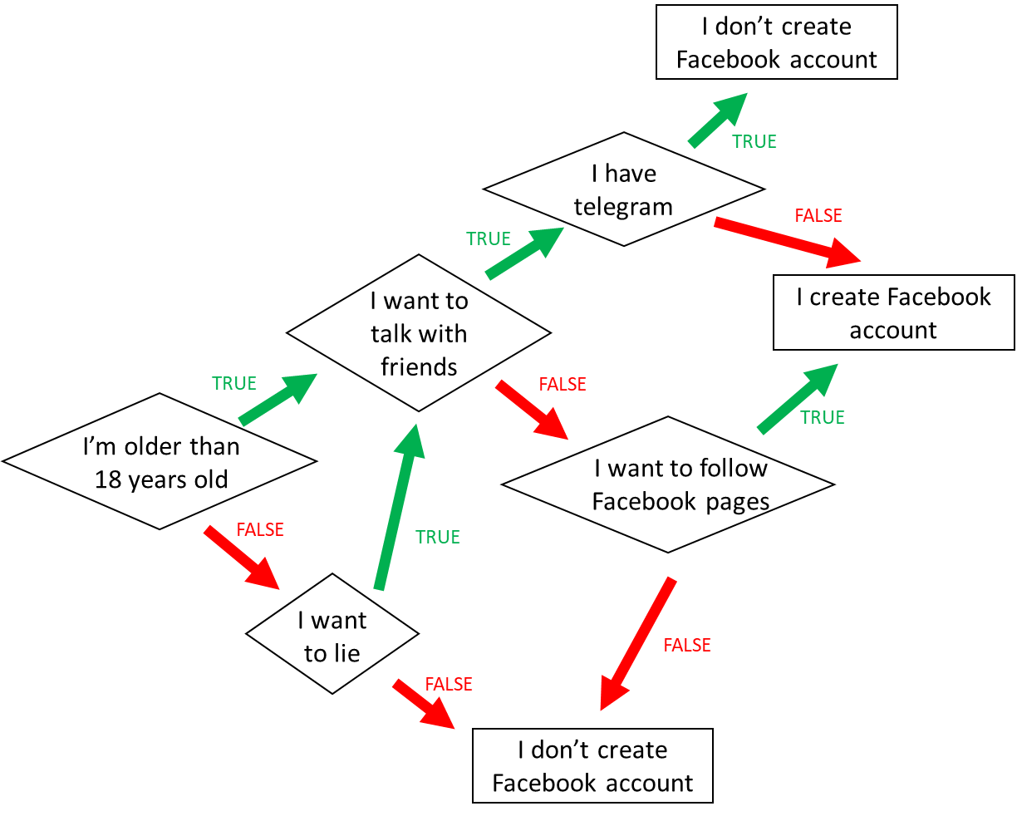

1. When do I create a Facebook account? (*Express the condition using a Boolean expression)*

*I’m older than 18 years old and i wantto talk with friends and i want to follw facebook account and i create facebook account.*

1. When **don’t I** create a Facebook account? *(Express the condition using a Boolean expression)*

I’m older ther than 18 years old and i want to talk with friends and i have telegram and i create facebook account.

Ex5: Create the chart flow

**Q1** Complete the char flow to follow those rules:

* If I am a girl and it is sunny, I wear a skirt
* If I am a girl and it is not sunny, I wear jeans
* If I am a boy and it is sunny, I wear a short
* If I am a boy and it is not sunny, I wear jeans

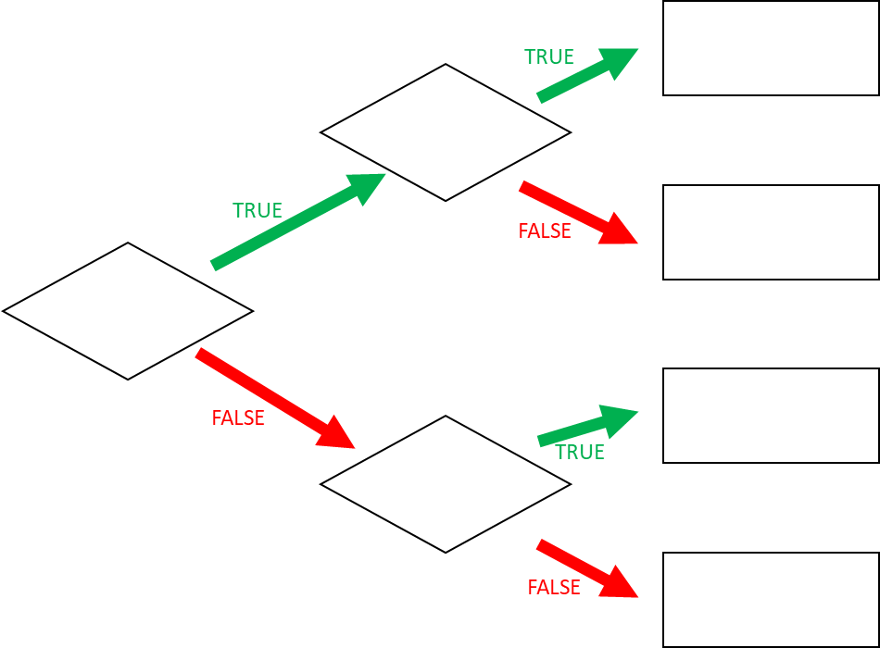

jeans

short

boy

jeans

skirt

sunny

girl

**Q1** When do I wear jeans? *(Express the condition using a Boolean expression)*

Non’t a Girl and l’m a boy and i wear jeans.